FACESTU

Mobile application developed by students for students. The main goal of this application is to help students connect with each other. Since they are studying at STU, they most likely share similar interests and our application makes it easier to connect between people who share interests. Students can search for useful information left behind by previous or older students, post their own thoughts and experiences, look for upcoming school events, chat with each other, and enjoy their university life on full blast.

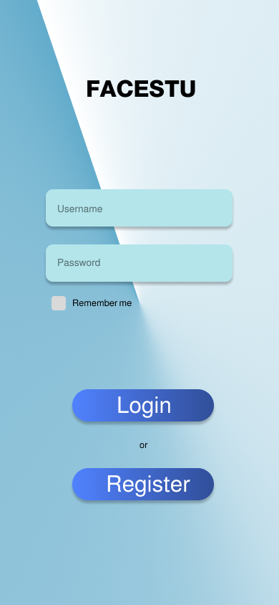

Login made simple, upon registration, the user can create unique username associated with his account and when logging in, he inputs the unique username and his accounts password, to continue to the home screen.

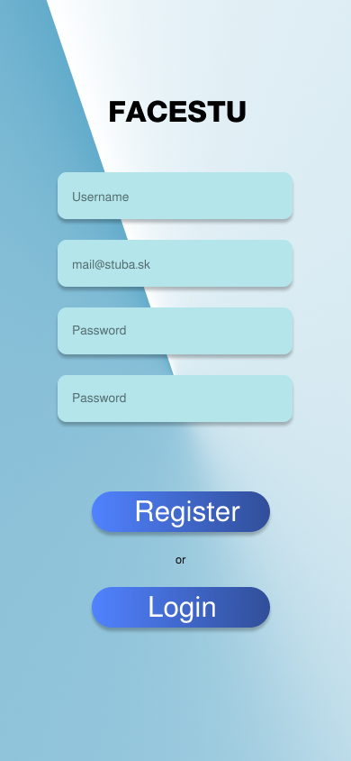

Our application is only designed for students. No one else has access, only those with *@stuba.sk* email domains. With this we achieve uniqueness among social media applications, and make their first and upcoming university years more interactive, social and fun. When the user is registered, he is redirected to the home screen, where he can find all things necessary to begin his university life journey.

Flutter as frontend language

As we are developing cross-platform application, to work on both devices we chose a language that shares code bases, is updated frequently and its syntax is not so difficult to learn. Resembling MVC frameworks, it is best for modular applications, requiring the use of components of the same nature.

JavaScript for the backend

JavaScript is an extensible and dependency reliant language which works perfectly for our application. With the use of the ExpressJS framework, socket.io and pg modules, we are ready for fast, reliable and maintainable API for our application.

User Acceptance Tests

|  |  |
| --- | --- |
| **Test 1** |  |
| **Input requirements** |  |
| **Output Requirements** |  |
| **Sequence:** |  |
| **Result:** PASS/FAIL |  |

|  |  |
| --- | --- |
| **Test 2** |  |
| **Input requirements** |  |
| **Output Requirements** |  |
| **Sequence:** |  |
| **Result:** PASS/FAIL |  |

|  |  |
| --- | --- |
| **Test 3** |  |
| **Input requirements** |  |
| **Output Requirements** |  |
| **Sequence:** |  |
| **Result:** PASS/FAIL |  |

|  |  |
| --- | --- |
| **Test 4** |  |
| **Input requirements** |  |
| **Output Requirements** |  |
| **Sequence:** |  |
| **Result:** PASS/FAIL |  |

|  |  |
| --- | --- |
| **Test 5** |  |
| **Input requirements** |  |
| **Output Requirements** |  |
| **Sequence:** |  |
| **Result:** PASS/FAIL |  |

|  |  |
| --- | --- |
| **Test 6** |  |
| **Input requirements** |  |
| **Output Requirements** |  |
| **Sequence:** |  |
| **Result:** PASS/FAIL |  |

|  |  |
| --- | --- |
| **Test 7** |  |
| **Input requirements** |  |
| **Output Requirements** |  |
| **Sequence:** |  |
| **Result:** PASS/FAIL |  |

|  |  |
| --- | --- |
| **Test 8** |  |
| **Input requirements** |  |
| **Output Requirements** |  |
| **Sequence:** |  |
| **Result:** PASS/FAIL |  |

|  |  |
| --- | --- |
| **Test 9** |  |
| **Input requirements** |  |
| **Output Requirements** |  |
| **Sequence:** |  |
| **Result:** PASS/FAIL |  |

|  |  |
| --- | --- |
| **Test 10** |  |
| **Input requirements** |  |
| **Output Requirements** |  |
| **Sequence:** |  |
| **Result:** PASS/FAIL |  |